You Can Play, Coach or Umpire
Floorball!

Written by

Jarkko Härkönen
The Head Coach and
Vice Chairman of the Technical Committee
Floorball Federation of India (FFI)
3rd Oct 2004, India
1 Introduction 3
2 What is floorball? 4
3 Who can be a floorball coach? 6
4 The basic rules for starting your first game of floorball 8
5 Coaching floorball 10
5.1 Speed 10
5.2 Team play 11
5.3 Stick handling 12
5.4 Exercises: basic and advanced 13
6 Refereeing 18
6.1 Movement on the field 18
6.2 Developing your game eye 18
6.3 Possibility for International referee experience 19
7 Membership of FFI 20
7.1 Introduce the ID-card system 20
7.2 Payment 20
8 Rules of Floorball 23
9 Closing words 24

Introduction
This booklet is written after noticing how motivated a newbie is to learn the game better here in the Great India. This booklet is meant to upgrade the knowledge of anyone who wants to increase their personal stamina by playing floorball, team playing skills, social life or to have a target to go professional in this game.
The game has shown so good prospects all over the world that we call this game as the game of today. Its remarkable potential to be the number one sport in schools have already taken place in Finland, for instance. Unofficially it is evaluated that around 10% of the population of Finland is playing this game as a one form of their regular sports activity (including association members and non-members). International Floorball Federation (IFF) have evaluated the number of all members of floorball in the world to be over 1,5 million (15 lachs), in the year 2002. There are over 30 IFF member countries in the world.
If you want to learn the basics of this game, then you should read this booklet through carefully. If you want to be a coach for this game then you should study this booklet even more carefully. And for people who want to be referees: concentrate on chapter 6 and learn the rules of the game.
This is the first ever booklet written also in hindi for the people of India. The invaluable information to boost this game in India is in your hands. Now it’s up to you how you use this information to benefit your own or your society’s future. All the doors in the house of floorball are open for you.
Floorball Federation of India wishes you all the best on your way to be inspired by floorball – The Game of Today!

“If you believe you can, you can.
If you believe you can not, you are also right.”
– Henry Ford, Founder of Ford Motors Co. Ltd.

What is floorball?
Floorball is a game where you play as a member of your team. The game is so fast that after 4 minutes of good game you actually want to be substituted and that’s more time than the professionals are usually spending on the field per substitution! There are no age limits and this is popular game among boys and girls – men and women.
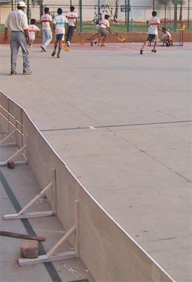
Field is 20 by 40 meters and the speed of the game is high because the semi-oval border is surrounding the field. This side border is 50 centimetres high and it is easy to jump over it when you are substituted along with your attacker or defender line. It’s also enough high for keeping the ball inside the rink. However, sometimes the ball goes over the side border and the game is continued with hit-in by the opponent (opponent to the one who touched the ball last) team player from the spot. Ground can be any flat, smooth surface from a stone/concrete floor to wooden indoor hall. Goals are width=160 by height=115 centimetres and goal keeper is sitting on his/her knees in front of the goal trying to prevent a goal. Goalie can use any part of his/her body for preventing a goal.
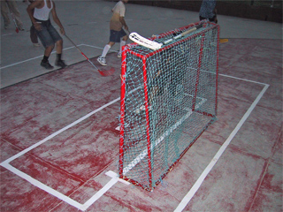
Players are not using any guard because the equipments are so light (some players are using sim-guards). Weight of the ball is only 27 grams so you can easily understand that it hurts only as much as pinching your skin if the ball hits you 100 km/h! Stick is about 300 grams and 95 cm long. Only goal keeper is using a helmet (a cricket helmet can be good for a start) and knee-cups or -pads on his/her knees. Latter one is for improving comfortness only.
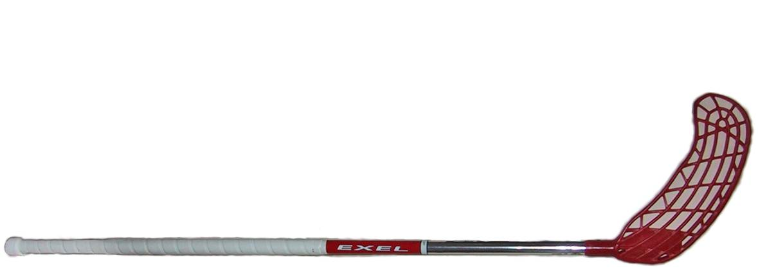
A team is usually consistent of 3 lines, each line having 5 field players. While one line is playing, the others are resting/ substituted. It’s up to the team’s couch how fast the substitutions are made. No, you do not need to ask any permit from the referee to do your substitutions. Only rule for substitutions is that the field player is first out of the field and then simultaneously fresh player is sent in to take his/her place and continue playing. This is encouraged for keeping up the tempo of the game high.
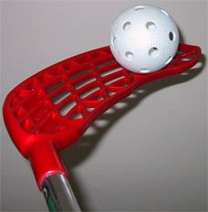
Shooting in floorball is easy with light (about 300 grams) stick and ball. Lots of stick handling and tricks are included in this game only because of the light weight of the equipments. Shaft is easy to bend for better ball control; just give a little heat to the shaft, mould it and put it in a bucket of cold water. This is actually the very essential point why people have tendency to continue with this game after trying it once: it gives you thrilling, enjoyment and good relaxing time with colourful situations. There’s also a saying: neither audience nor player can play/watch a full game of floorball without having one good laugh!
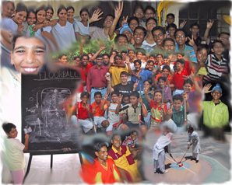

Welcome to enjoy and learn the basics of Floorball!

Who can be a floorball coach?
You!
Hmm…Maybe that’s not enough for this chapter, so let’s tell more! If we simply turn it other way around and we ask: Why you can not be a coach for this game?
You can not be a coach, if you want to do rather something else than coach floorball. Ok, decision is done? You are most welcome to continue further with this chapter…
Floorball is a very new game in India, so you just have to be motivated to be part of this and you’ll have good chances to develop yourself to as high level as you want to achieve. FFI is certifying coaches and referees for local associations after special certifying seminar, held by a member of the technical committee - FFI. Local association is able to organize the seminar for some reasonably large group (10 people for an instance), so you better just contact your local association representative. All contact details are possible to find from www.floorballindia.org. (because of constant updating they are not mentioned in this booklet.)
What kind of personality is good for a coach? From my own experience I can list few and rest, as well as the psychology of this subject is available in libraries. I have noticed that these characters are helpful for you:
- Patience
- Understanding
- Empathy
- Sense of humour
- Positive attitude towards different people and life
- Altruism
- Ability to have “a bird perspective” in conflicts
- Communication skills
- Kind and easy to approach (by a child for example)
- Leading with own good example

It is easy to continue this list, but if you associated yourself to some of above mentioned characters, then you have the right attitude for coaching floorball.
Because floorball has a tendency to give lots of good social moments, a coach should never forget the necessity of a relaxing game session after exercises. This is more important when you are coaching small children – a game before ending the practice session is the reason that keeps them motivated to practice seriously, so don’t forget to let your players have a good relaxing enjoyment after you have taught them so many new things during that particular practice session!

The basic rules for starting your first game of floorball
No borders, no rules?
Very often this game is played on a ground where there are no ready-made side-borders, i.e. on a basketball ground. It means that we have to modify the rules (modified to use in India only. These are not official!).
With these following rules you are able to start your first game of floorball, one calls this as a recreational form of floorball. Modifications of the rules are good especially when the players are beginners…
- Goal posts can be anything from shoes to sticks, from hockey goals to two garbage bins. But if you have goals already, then you have no probs.
- Playing without side borders can mean that there are no hit-ins. When the ball goes off the (ie. Basketball) ground, you simply let the nearest to the ball to fetch it back and you continue normally. However if you have borders available, you follow the rules of hit-ins as per in the rules of floorball.
- Goal keeper’s area can be painted on the ground with white paint, but you can play without it just fine. Goal keeper can play with or without a stick, but prefer without, because then adapting the right way of playing is easier. Goal keeper needs usually some knee-cups for sitting on his/her knees – if not available, goalie can use one knee only to keep his/her body balance low when protecting the goal and standing when there are no opponent’s attackers around.
- Starting (of a period or after a goal) happen normally from the centre point of the ground.
- Game time can be anything from 1 minute to 1 hour. It’s really up to you. Use your stop watch for ie. 3 minutes of frequency for substitutions.
- There can be 3 vs. 3 and no goal keeper or 6 vs. 6 and goal keeper…it all depends on the size of the ground you are playing on. On ie. Basketball ground it’s more enjoyable to play 4 vs. 4 plus goal keepers than 5 vs. 5 plus goal keepers. Test it and you will feel the difference when there’s not so much room to give good passes.
- High stick (a player touches the ball with stick above knee level) is very common foul with beginners, so you can modify this, too…just don’t be too sensitive referee. Think about the waist-level rule (the player is allowed to swing his/her stick to this level when shooting) with your common sense: Instead of strict following of the rule(s), you can whistle off only the most outrageous fouls.
- And yes, in this game you can touch the ball with your foot and both sides of the shaft are in full use. Just select your side – are you left or right handed? Compare hockey where only one side of the shaft is allowed to use.
- Beginners (especially with hockey background) tend to raise their stick when shooting the ball. It’s good that you all go through what’s the difference between a hockey stick and floorball stick before you start. One can say: compare tennis and badminton; in badminton you use your power more “sophisticated” than in tennis…same is between hockey and floorball – more gentle touch in the latter one is preferred. One can also improvise this by shouting a brutal grunt sound when swinging the stick like someone was swinging with a golf club. Only with proper instructions you can manage your players well in initial stage: remind them of the right grip on the stick…say ”Widen your grip so that it doesn’t look like you guys are playing floorball with a golf club!”

Now you should have enough modifications to start your first game with or without right sized goal posts or side borders. Remember that for recreational purpose, one can re-modify the rules as much as one will. This is a recreational form of floorball and the relaxing feeling can be caught only by the relaxed players.
However, it’s not a good idea to change your equipments. For example playing with tennis ball can break your stick or shaft of your stick. Stick can be shortened though for young/short players by 10-15 cm. This is the way to easier stick handling, so encourage your players as a coach to saw a bit off from the grip-end of the stick.

Coaching floorball
This chapter is divided into different sections for keeping it clear that you can always work only in these categories. For a good player there are three major areas to always improve more in floorball. These are:
- Speed of interval run
- Team play
- Stick handling
Let’s go through some exercises for each category to give an idea of how to coach floorball.

Speed
Because this game is very much about running, one has to improve his running in all areas if he wants to be a good player. Player’s stamina will increase automatically when he plays floorball, but you can include jogging to improve your players in this area. Abs are commonly known also as running muscles, so concentrate on that. There are lots of good exercises available for abs and there is not only one right exercise for these or any other muscles. It’s actually always better to have different variations for the same area muscles.
Exercise the legs also…yes, let’s not forget the legs. Good exercises for calves and thighs are essential to increase the speed of your players. You can exercise legs with so many ways…i.e. running steps up and down is one good way to get durability to your players’ legs. Other one is maximising the strength of leg muscles: a player is carrying other same size player on his back and then going up and down by bending his knees.
To find out how good runners your team has, do one thing: time a 60m distance of each player individually. Those who are weaker in this area will be encouraged by you to improve their speed.
Hand muscles are important for faster shooting. Simple push-ups should do fine in the initial stage of your team.

Team play
Let all have a change to give the best output they can give. Substitutions’ importance is better to learn right from the beginning. Because of the high game tempo, it’s better to substitute players after ~2 - 3 minutes. A good time for substitution is when your own side is having a free hit or hit-in. Then you as a coach, call all from that particular line to rest and send the next substitution line in. It’s important to just let the ball be untouched (after it has bounced over the side borders) and come to substitution all together. As a coach you should make that clear to you team that from a signal (you call them basicly) they all come off the field without any hesitation. This team discipline allows you to manage your team very efficiently.
Team play means always passing and working as a player who is not controlling the ball at all – these players have important role when your tactics include misleading the opponent’s player(s). As a coach you have to make your players to understand that all are doing equally important work on the field – only together you can win. Even though this game is allowing individuals to have a good scope for scoring and dribbling, you have to find how i.e. the attackers are playing well together. If someone is good shooter then give him a function that allows him to be positioned in the good shooting range. What ever tactics you are about to use when attacking try always to end it to the good shooting area for a good chance for scoring.
Good shooting area
With passing exercises you can get your team to understand the importance of passing. One good exercise is to play 2 vs 2. this exercise means only 1-2 minutes of game on half of the field in use. If you use an exercise like this, your players are having no other options but passing and running to good positions for being passed to or to be able shoot.
Always as a coach it’s important to find good examples from your team and to give others an example to follow. Encourage these good examples and support them so that others can hear that too. All your players want to please you, so if they manage to do so, acknowledge that. With good healthy team spirit your team is very strong in tough situations, under pressure. Don’t underestimate this perspective.

Stick handling
Before you are able to execute your inventive tactics, your team has to have some level of stick handling skills. For that there are numerous of exercises again. Use your imagination and give incentives for learning through small inter-substitution line competitions. There are some useful exercises for encouraging your team members to practice on their own time at home for example.
In these pictures you can see how an individual is able to practice alone when he’s dribbling the ball between his feet with his stick a) and he’s doing a shape of an eight (8). Other picture is showing how two players can use all the skills they have to control the ball. Aim in the picture b) is to control (star is the controller) the ball inside a small area. Opponent (round shape) is trying to take the ball from the “star”. If he manages in this then it’s his turn to be the controller. However if the ball slips outside of the imaginary small 1,5 by 1,5 meters area then the turn changes as well. Remember, it’s not wise to be too strict with the area sidelines because this exercise will become too hard. Only then when the ball control is totally lost, then the turn changes. You can also expand the area if you wish.
1,5m
1,5m
Left and right foot
1,5m
a)
b)

Exercises: basic and advanced
Here are some basic exercises first to give you an idea what kind of exercises you can modify for higher skill levels. Remember that internationally these basic exercises are done in almost every team for warming up players and goal keeper – so, when your team is mastering these, you know that you can give them more complicated exercises. In pictures, dashed line means a pass and solid arrow means running (with or without ball).
  - This exercise is supposed to be the very first for your players to go through and to master. As you can see, there is only one queue per corner. One is passing (dashed line), other is running and doing a little u-turn near the centre line. It’s important that the player who is shooting, receives the pass right after the u-turn. That is for improving the player who’s passing. Accuracy and timing are the key factors in this exercise. Shooter needs to receive a pass – even if it’s not a perfect one. We all know that in the real game, there can be what-ever-kind-of-passes, so shooter needs to move accordingly. Use the ground effectively by lining the players to all four corners. After one pair is done, they change sides and the next pair starts.
A)
  - This exercise is good for all to see how difficult situations they are facing all the time during the real game. The thing is that the most common situation in floorball is 1 vs. 1. So let’s modify A) just a little bit: after passing to the player who started from the left upper corner, the player (who passed) has to run to somewhere on the front line of the goal keeper’s area and start defending and we have 1 vs. 1 situation.
B)
  - This exercise is a bit more difficult after B). This is called the pass-cross-pass –exercise. It simply means that the player must be able to pass while running. Receiving must also happen while running. If you look at the right hand side upper corner and follow the arrows, you are definitely able to understand this exercise. Player is running while controlling the ball, other side is coming same time so he passes to the other side attacker. After that they run across and the latter controller of the ball passes it back to the one who started running with the ball. We have completed pass-cross-pass. After that the player whoever is controlling the ball is facing an alternative to shoot or pass. He takes a quick look to the goal keeper and makes his own decision… the aim of this exercise is to have a good shoot, so both are equal for that decision.
C)
  - This exercise is again one higher in difficulty level compared to the previous one. Just add one player to disturb their attack after pass-cross-pass has taken place. This defender line is good to place next to the goal post. Only 2-3 defenders are necessary, you can always change them to fresh defenders. You can increase or decrease the difficulty level of this exercise by just telling the defenders to be aggressive or semi-aggressive.
D)
As one can see, these exercises are very modifiable, one can even start from the centre line to go through these 2 against 1 -exercises. You will have your own imagination to decide what kind exercises are feasible and which are not.
A)
B)
Now we go through some playing tactics:
Defending when short-handed (4 vs. 5)
Let’s view also some advanced exercises for teams who already have the basics of stick handling and positioning on the field. About positioning, see these for understanding different situations: when playing short-handed, A) and B) are showing the options how to place your players on the field. In A) players (o-shape) are defending against attackers (Δ-shape). In 4 vs. 5 situation it’s better to be like shown in A) (upper part of the field).
If (see triangles head down) attackers are positioned as in lower part of the field B) then it’s more effective to defend by forming a square area in front of your own goal (see o-shapes).
Power Play
Now you can same time see two tactics for power-play as well. See how triangles are positioned on the field. The head of the triangle is showing the attacking direction. In A) we have only one defender on the centre line. He is the one who is being passed many times for giving pressure to the defending opponent. When shooter is getting an opportunity, he shoots. Shooter can be in front of the goal or right next to the side border. The job of the one triangle in front of the goal is usually to disturb the goal keeper and shoot the bounced ball to goal.
In B) you can see the other basic option for power-play. In this, defenders are passing a lot to each other and passing to attackers when the moment is right for open possibility of a shoot. Shooter is usually the one who is in the middle of the five players. He can also be just disturbing the defenders if the shooter is on left or right side from middle.
A)
B)
Opening an attack
Basic situation of the players when they are starting an attack from their own side of the field is 1-2-2. See the picture: Lowest defender is standing behind the goal and getting a pass from his goal keeper or from the second lowest defender for calming down the situation of the previous attack. Now the field players are ready to start their attack. Aim is to get the ball to the lower left corner of the field. Let’s not forget now that you can do this opening attack to both corners. After getting the ball to the corner, attack is free. The idea of opening an attack like this is that there’s really small chance of counter attacks. This is the safe way of getting the ball up to opponent’s end of the field. Of course you as a coach can use any method for attacks, just remember that it’s always more safe to attack via the left or right side of the field than attacking through the middle of the field.

Defending
Defending can be aggressive or passive. If you select aggressive defending, then you need 1-3 attackers who are aggressively disturbing opponents opening of their attack. Like in picture A), this is always little bit risky but you need it if your team is behind by one goal and there’s not much time left of the whole game.
When you select passive defending, your players are awaiting just behind the centre line and only when the opponent is crossing the line you start aggressive defending. When the situation is like this, you need to shock your opponent by attacking with 2 against 1, see the picture B).
A)
These tactics are easiest to practice while playing a practice game. You just stop the game every now and then and tell the players not to move after whistling. Then you see who is defending against who and who is situated right or wrong. This is very good learning experience for the players.

B)

Refereeing
Referee is the king on the field and his decision is the law! If players are protesting, you cannot change your opinion. If you do so, you will loose the authority on the field.
There are some basics for you to start umpiring a game. Read the rules of the game for better understanding.

Movement on the field
If there are two referees same time, then other one is the head referee and other one is assistant referee. The movement on the field is very much same for both of the referees, but it’s a mirror image. Both are supposed to run on the other side only. This keeps the perspective better for two pair of eyes.
After a penalty or a goal both referees go to the time table secretary for registering the event.
If the game is not official or it’s between young players only, then there’s necessary to be only one referee. In case of one referee, he is supposed to keep his eye on the players all over the field. But as a good referee, you try to stay out of the situations, so don’t run in the middle of the field. Stay next to the side borders and jump off the field if situation requires you to do so.

Developing your game eye
You can be a good referee only through experience. Be active and ask your association to organize test games if there are no games for you to practice your refereeing. As a referee of beginners, remember to “read” the situations properly; if there’s no dangerous playing then a high stick is not requiring a penalty. If you want to teach the beginners when they play then you better give a 2-minutes penalty from every major foul they make.

Possibility for International referee experience
FFI needs to qualify international referees. This means seminars and refereeing abroad. To be able to qualify as an international referee, you will need experience and deep understanding of the rules of the game. There are no international referees from India so far…do you want to achieve this first? With floorball anyone can make it happen!

Membership of FFI
This unique way of running the federation is adopted from Finland. By collecting more members to the association, it’s easier to organise leagues and tournaments. The more members, the better recognition is available in official and/or political channels. The more members, the richer is the association and federation. The richer association and federation, the better organised tournaments and prizes!
How this works?
By following always the same procedure, we are all enjoying the game and there can be no misunderstandings:

Introduce the ID-card system
Only people, who are involved in the association and they are also members, can introduce the system. For that they need to show their own valid ID-card and explain the rates: 400Rs per player/supporting member per year and 200Rs per referee or coach per year.
System must be introduced by explaining the two major benefits: licence to play in official floorball matches and benefits of the insurance. Licensed card holder is entitled to participate in any training camp in anywhere in India with special discounts (mostly free of charge). Insurance is provided by United India Insurance (UII) and the policy regulations are free to copy from internet www.floorballindia.org or to order from your local association’s representative.

Payment
Each member has to renew the membership once in a year by paying the amount to the account of his/her association. Associations can/must handle cash payments as well.

Payment is consistent of three parts:
- 100Rs for the local association’s expenses
- 163Rs for FFI’s expenses
- 137Rs for United India’s insurance
Total 400Rs/player/year
Referee’s membership is sponsored by FFI and the association. From referees association is collecting the fee as follows: 50Rs for the association, 13Rs for FFI and 137Rs to UII – Total 200Rs.

Front and back side of the FFI ID-card:
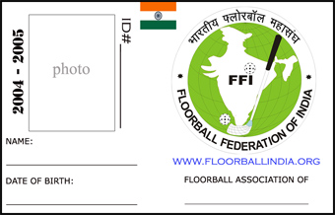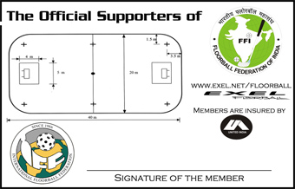

Associations are the collectors and will send 300Rs/membership to FFI. Associations are having a membership number-list from which they always take a fresh ID-number to a new member. They always have a proper stock of empty ID-cards and application forms for issuing the card on the spot when they receive applicator’s fully filled application form and payment.
In a nut shell:
- Your local floorball association collects the application forms and payments.
- They hold 100Rs for their expenses per application and send 300Rs to FFI.
- FFI registries members to their database and controls in official matches that there are no players playing without ID-card (license to play).
- Players can play official and unofficial games without worries of hospital costs caused by possible injuries.
See the membership application form from the next page: (insurance policy and this form are both possible to download from www.floorballindia.org)

FLOORBALL FEDERATION OF INDIA
Affix
Passport
Size photo Graph
3.5Cms × 3.5Cms
(Affiliated with International Floorball Federation –IFF, Sweden, www.floorball.org & www.floorballindia.org)

APPLICATION-CUM-REGISTRATION FORM FOR PLAYER

1. NAME (IN BLOCK LETTERS) :

2. FATHER’S NAME :

3. ADDRESS :

HOUSE NO :

STREET/MOHALLA :

TOWN :

POST OFFICE :

DISTRICT :

PIN CODE :

STATE :

PHONE WITH STD CODE :

D D M M Y Y Y Y
4. DATE OF BIRTH :

5. Have you suffered or do you suffer from (full particulars much be given in case the answer is “Yes” to any of the following questions)
(a) Any Physical Defect or Infirmity Yes / No
(b) Gout, Arthritis, Diabetes Paralysis, Fits of any kind or any other chronic disease Yes / No
(c) Any other Physical Defects or disability Yes / No

6. NAME OF NOMINEE…………………………………………..RELATION……………………………………

DECLARATION
I declare that the answers and information given in the above schedule are true to the best of my knowledge and belief.

Place:
Signature of Parent/Guardian
(In case of minor player only)

Date : Signature of Player/Applicant

------------------------------------------------------------------------------
FOR THE USE OF FFI

1. Received Registration fee Rs. 400/- in words (Rupees Four Hundred Only) cash /DD No… …………….dt. …………… Vide Receipt No. …………………....dt. for one year.

2. Recommendation by local chapter of FFI _________________________________________________
(Authorised Signatory)

3. ID No :
Registration Number

State Code

Rules of Floorball
I didn’t include the rules in this booklet. It’s too easy for you to contact FFI or your local association for getting the rules booklet. All the contact details can be found from the web page: www.floorballindia.org. From our web page, one is able to download the rules as well. It’s good to go through at least the signs of the referee for understanding the game better. Rules are not translated in Hindi so far, but translation will be done soon.

Closing words
Now it’s time to make a decision, do you want to continue with this game or not. If not, it’s ok: hopefully you can find something that satisfies your needs for enjoying your exercises. If yes, better; you are one of the pioneers of Indian floorball and your work for it is like writing history every day!
Floorball is going to be a huge thing in India. After being part of the official school sports of India it will spread all over like a bush fire. After getting recognition from the government of India it will be in all institutions. When this rapid expand is going to happen? Already in next year FFI has conducted its third national championships of floorball. There is this rule from the government side: before getting their recognition for the game, federation must be able to organize three national championships.
FFI is going to promote this game very actively and also pay to the promoters it has accepted. If you are interested in teaching this game in your local society, just contact FFI, info@floorballindia.org.
There is still lot of work to do in Great India and only together we are strong. My work is to give the initial boost for this game as a teacher and in the future my work is to get skilled floorball players to India for teaching this game more. Expenses will be covered by FFI, but salary is not possible in this initial stage of FFI. If you are interested in cultural exchange and ready to teach against expenses then you just contact info@floorballindia.org for further information.
I hope you have now all the info you need for your initial stage of starting a game of floorball in India and if you are advanced, then you have a golden opportunity to get more deeply involved in this game in India.
Thank you for your interest and…Let’s play floorball!

